Study Guide Integrated 2: Chapter 8

Directions: Use this study guide to practice Chapter 8 problems. The answers are listed below so that you can check your answers. This study guide is optional – but a great way to study! If you have questions about how to do any of these problems, check with your peers or email me!

- Two quadrilaterals are similar. The smaller has a perimeter of 20 cm and an area of 60 cm2. If the perimeter of the larger quadrilateral is 30 cm then the area of the larger quadrilateral is:
A. 40 cm2
B. 70 cm2
C. 90 cm2
D. 135 cm2
E. None of these
- Calculate the sum of the measures of the interior angles of an 83-gon.
- Calculate the value of x.
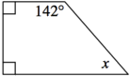

- Calculate the value of x.
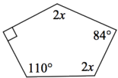

- If each exterior angle on a regular polygon has a measure of 12°, how many sides will the polygon have?
- An exterior angle of a regular polygon measures 18°.
How many sides does the polygon have?
- If figure A and figure B are similar with a ratio of similarity of 6, that is, 6 to 1, and the perimeter of figure A is 54 units, what is the perimeter of figure B?
- If figure A and figure B are similar with a ratio of similarity of 1/8 and the area of figure A is 13 square units, what is the area of figure B?

- Determine the area of the shaded sector in each circle below. In each case, point O is the center.
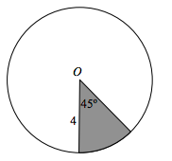

- Determine the area of the shaded sector in each circle below. In each case, point O is the center.
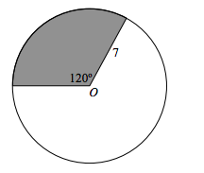

- How many sides does the regular polygon have if each interior angle has 156° measure?

- Calculate the measure of each interior angle of a regular 30-gon

Answer Key:
- D
- 14,580
- x = 38
- x = 64
- n = 30
- n = 20
- 9 units
- 832 sq. units
- 2$π$
- $\frac{49}{3}π$
- n = 15
- 168

